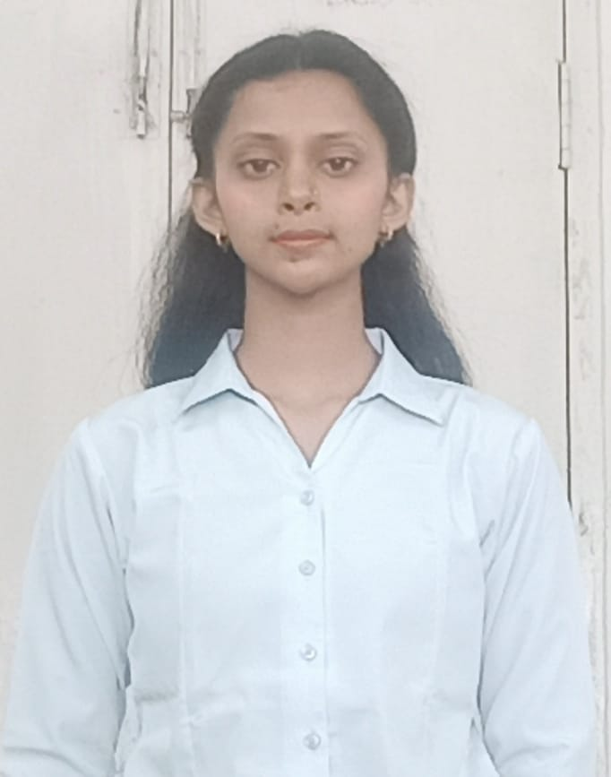

To secure an opportunity at your company where I can contribute my skills in development field and gain valuable experience in a dynamic and innovative work environment.

Objective

* Book Reading
* Chess

Hobbies

* Hard & Smart Work
* Honest & Punctual
* Communication skill

Strength

Aastha Patel

* Bootcamp DSA|crackDSA|2023
* Python|Udemy
* Object Oriented
* Object Oriented Programming|cousera
* English|Great Learning
* HTML & CSS |Udemy

Other Activities

* Nodal Badminton Competition and also in other curriculum activities of college.
* Mini project on Social media .

Work Experience

* Fresher

Certification

* Strong problem-solving and analytical skills.
* Understanding of DSA.
* C ,C++,HTML,CSS,JS,Python training , which was organised by my college.
* Familiarity with HTML,CSS,JS,Python.

Technical Knowledge

* Pursuing B.Tech from Sagar Institute of Science and Technology, Bhopal, Madhya Pradesh.

Current C.G.P.A.—7.7

* 12th from State Board in 2020 with Marks 86%
* 10th from State Board 2018 with Marks 96.2%

+919589963951

 [aasthap1030@gmail.com](mailto:-aasthap1030@gmail.com)

Bhopal-MP

Educational Qualification